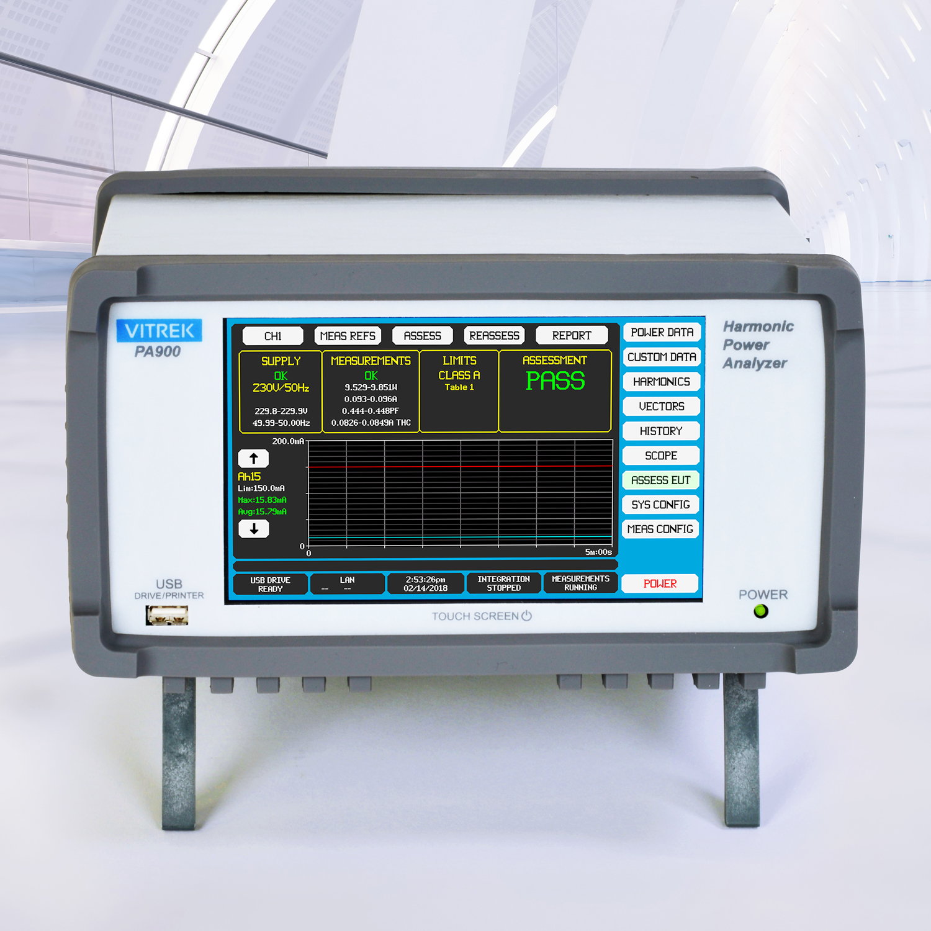

Vitrek Power Analyzer Performs Compliance Testing to International Standards
The PA900 features built-in capability to perform compliance analysis for a selection of key motor drive, standby power, harmonics and avionics standards – without using PC-based software

Poway, CA—March 9, 2018—Vitrek, a leader in high-voltage test and measurement equipment, introduces the latest generation of its popular line of power analyzers, now equipped with the built-in capability to conduct compliance testing to a number of key environmental performance standards. The PA900 Precision Multi-channel Harmonic Power Analyzer can be set up to analyze the power output or consumption of the device under test and automatically display the results. This is a significant advance over other power analyzers requiring PC-based software to conduct such analysis.
The PA900’s test results are selectable for the following environmental/performance standards:
- EN60034-2-1:2014 (motor drives)
- EN50564:2011 (standby power)
- EN61000-3-2 and 3-12 and 4-7 (harmonics emissions)
- RTCA DO-160E/F/G (avionics)
- Boeing 787B3-0147
- Airbus ABD0100.1.8 (A380) and ABD0100.1.8.1 (A350)
The PA900 sets the standard for affordable graphical power analyzers. It integrates a high-accuracy, wideband waveform digitizer with advanced computational capability, a large high-resolution display and a full-color touchscreen user interface. The unit’s intuitive touchscreen operation – with built-in data history, scope mode and waveform zoom – allows users to explore many aspects of power measurement in greater detail than traditional power analyzers.
The PA900 delivers waveform visualization and measurement results necessary to validate the performance of power critical designs, such as LED lighting, solar power inverters, electric vehicles and aviation power distribution. Its Virtual Power Analyzer function facilitates energy-efficiency measurements, while its 0.03% basic accuracy and (up to) 5MHz bandwidth provide world-class performance. In addition, the PA900 now includes the capability of measuring up to 500th harmonics and multi-unit linking for as many as 12-channel applications.
“The simplicity of having built-in compliance testing to key industry standards is a significant differentiator of the PA900,” said Kevin Clark, Vitrek’s CEO and Chief Technology Officer. “Competing power analyzers that can cost more than twice its price still require moving the data to a PC to conduct the analysis.”
Price: $2,490 (single channel, standard performance) - $6,375 (four channel, high-accuracy)
Delivery: Stock to 2 weeks (ARO)

About Vitrek
Since 1990, Vitrek has provided innovative global solutions for high voltage test and measurement including electrical safety compliance testers, multi-point high-voltage switching systems and graphical power analyzers. Vitrek also supplies precision high voltage measurement standards to national laboratories and calibration labs around the world. This unique combination of capabilities positions Vitrek as a leading provider of test solutions serving the photovoltaic, medical equipment, power conversion, electrical component and appliance industries.

Company Contact:
Kevin Clark, CEO
Vitrek, Inc.
858.689.2755 x202
kclark@vitrek.com

www.vitrek.com
Agency Contact:
Greg Evans • Acct. Exec.
WelComm, Inc.
Direct: 858-633-1911
greg@welcomm.com
www.welcomm.com

