Vitrek’s QT Enterprise Electrical Safety Software Manages and
Records Test Procedures
Platform facilitates electrical safety test sequence setup, report creation and data archiving; SQL database of test procedures and results accessible from multiple PCs, bar coding feature enables accurate application of production test sequences
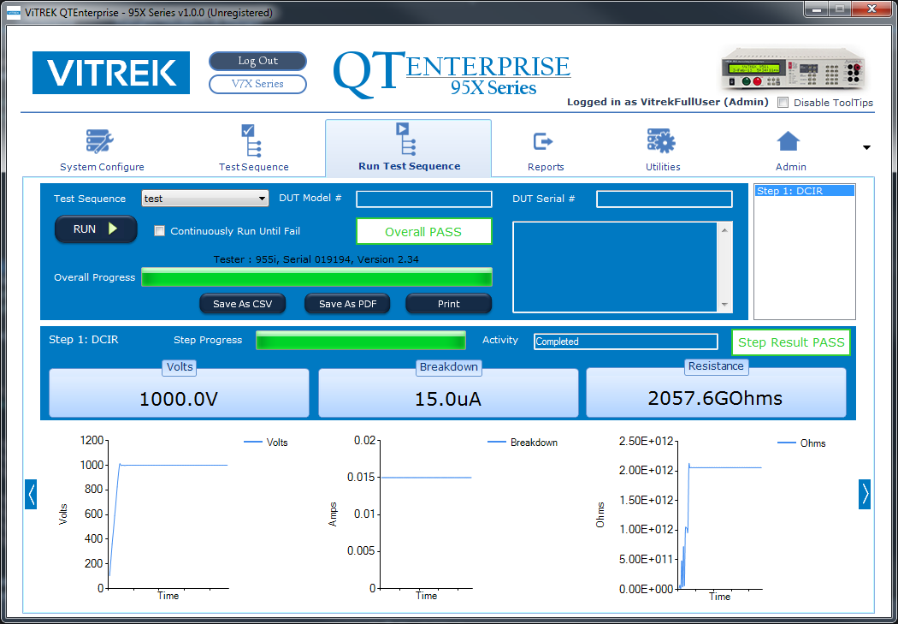
Poway, CA—July 25, 2019—Vitrek, the leader in high-voltage test and measurement equipment, introduces QT Enterprise, a major upgrade to its PC-based software designed to control operation of the company’s V7x and 95x lines of high-performance electrical safety (hipot) testers and 98X Series insulation resistance testers. In test situations where multiple test points are involved, the QT Enterprise platform can interface with Vitrek’s 964i High Voltage Switching Systems to further automate the process. For complex setups, QT Enterprise can display detailed instructions and images to the operator to ensure proper connections prior to testing.
[click on image to download hi-res png]
QT Enterprise is a feature-rich safety testing software platform, providing time and cost saving features:
- Configurations, test sequences, test results, users and other system settings are stored on a local PC or in a central SQL database accessible through a network
- Test data is easily accessible, and user may sort and filter a list of results based on your specific needs
- Integrates with barcode scanner to read DUT model and bring up the correct, ready-to-run test sequence
- Multimedia setup instructions can be incorporated into test sequences providing operator with visual prompts for easy and accurate DUT hookup
QT Enterprise records the results of every test. By using filtering functions provided, individual tests can be recalled for auditing purposes or detailed analysis on testing or product performance. Results of recalled tests can be saved as PDF or CSV as if the test was just performed.
QT Enterprise provides a clean and intuitive means for creating and modifying a virtually unlimited number of electrical safety testing procedures. Each test sequence can have as many as 999 steps to perform a comprehensive range of electrical safety tests including AC and/or DC voltage withstand, insulation resistance, ground bond testing and others.
QT Enterprise only communicates with the tester (and optionally, the switch units) when required to do so. Consequently, computer setup to define users, system configurations and/or test sequences can be performed without connection to interface hardware or the units themselves.
To learn more about Vitrek’s QT Enterprise Software and full line of High Voltage Test & Measurement Products visit www.vitrek.com
Price: $995 (QTE-7 Version for V7X Power Analyzers)
$1495 (QTE-9 Version for 95X Power Analyzers and 98X Insulation Resistance Testers)
Contact factory for upgrade pricing from QTPro software
A 45-day free trial is available for download.
Delivery: In Stock

About Vitrek
Since 1990, Vitrek has provided innovative global solutions for high voltage test and measurement including electrical safety compliance testers, multi-point high-voltage switching systems and graphical power analyzers. Vitrek's recent acquisition of the XiTRON brand of high performance instruments expands the company's portfolio to include portable calibrators for thermocouple and millivolt DC calibration, ballast testers, LED illumination spectral analyzers, programmable DC electronic loads, phase-angle voltmeters and digital milliohmmeters. Vitrek also supplies precision high voltage measurement standards to national laboratories and calibration labs around the world. This unique combination of capabilities positions Vitrek as a leading provider of test solutions serving the photovoltaic, medical equipment, power conversion, electrical component and appliance industries.

